Remaining Course
DEPARTMENTS: AGRICULTURE AND FOOD PROCESSING.
Academic Year: 2019-2020
Semester II
LEVEL: Three.
Module Name: FRUITS AND VEGETABLE PROCESSING TECHNOLOGIES AND QUALITY ASSURANCE PRACTICES
Module Code: WKSH 301.
MODULE 5: FRUITS AND VEGETABLE PROCESSING TECHNOLOGIES AND QUALITY ASSURANCE PRACTICES
UNIT OF COMPETENCY: BEVERAGE PRODUCTION
UNIT ONE: BEVERAGE PROCESSING

0.3. BEER PROCESSING FROM LOCAL RAW MATERIALS

SORGHUM BEER PROCESSING
Beer is a fermented beverage. Made by the extraction and partial conversion, through malting and mashing, of cereal starch (most often barley) into fermentable sugars. Hops are usually added. Fermentation is performed primarily with yeast(s), with part of the resulting carbon dioxide retained in the beverage. The beverage can be served unfiltered or filtered. Sugars in any form (unmalted adjuncts) may be added to the beverage at any stage of production.
- Beer is a fermented beverage brewed on malted cereal grains
- Malting is a process applied to cereal grains, in which the grains are made to germinate thereby developing enzymes that enable transformation of starch into sugars.
- Brewing is a broad term covering the transformation of starch into fermentable sugar.
- Cereal grains used: Barley, Wheat, Rye, Oats and Sorghum
African sorghum beer is a brownish-pink beverage with a slightly tangy and sour taste. It has an alcohol content that can vary between 1% and 8%. Its appearance is cloudy and is traditionally consumed at room temperature. Sorghum beer is known by many different names in various countries across Africa, including Burukuto (Nigeria), Pombe (East Africa) and Bil-Bil (Cameroon).
Ingredients:
- 1 kg. (2.2 lbs.) Sorghum
- 7g (1/4-ounce) Baking Yeast
Directions:
- Soak sorghum in water, allowing it to begin germination.
- Dry the partially germinated grains.
- Crush the sorghum and boil in water for about 15 minutes.
- Drain and put into a large vessel.
- Add 4 liters of hot water and let sit for 1 hour.
- Transfer liquid portion of mash to a large vessel and add 8 liters of hot water.
- Let the mixture cool naturally until reaching room temperature.
- Add the yeast and one cup of additional crushed sorghum malt (from germinated grains).
- Stir vigorously.
- Ferment for 2 days at room temperature then strain beer into storage vessels.
- Serve to thirsty customers.
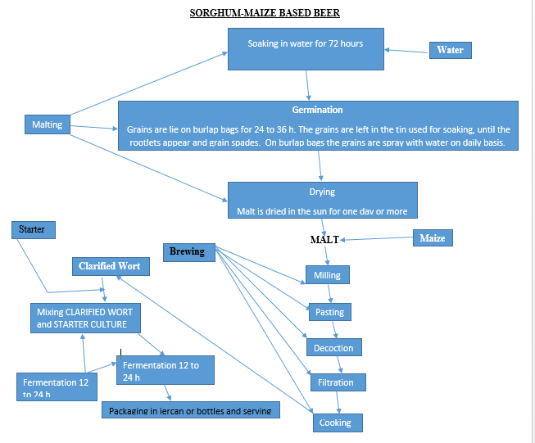
Fig1: Sorghum –Maize Based Beer

EQUIPMENT AND TOOLS:
Cooker, Cooking pots, Cooking spoons, Graduated jugs, Alcohol meter, Hydrometer, Refractometer, Packaging material, fermentation tank, …
